Intel® Celeron® Quad Core processor
Fanless Industrial Computer
IBOX-1026

Features：
◇ All aluminum structure，fanless design；
◇Onboard Intel Celeron J4125 Quad Core processor；
◇ Support 2*Intel i211-AT 1000M LAN；
◇ Support 1*M.2 Slot,1*Mini PCIE Slot；
◇ Support WIFI/3G/4G (Three choose one)
◇ Support 6*COM,COM1 Support RS485；
◇ Support OS：



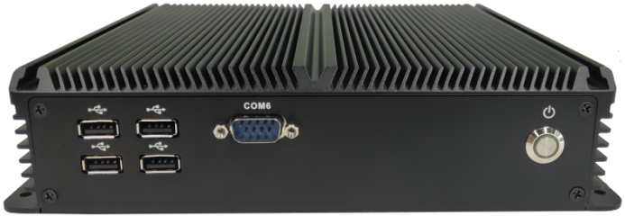
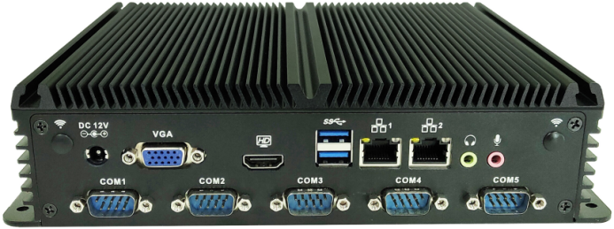
Specification
Model | IBOX-1026
Color | Black（Color can be customized）
Material | High-quality all aluminum，surface anodic oxidation
Processor | Onboard Intel Celeron J4125（Quad core quad threading，4MB Cache，2.0GHz，turbo 2.7GHz）
CPU Architecture | Gemini Lake Refresh
RAM | Support 1*DDR4 2400MHz SODIMM Memory Slot，Max. Support 8GB
BIOS | AMI UEFI BIOS
Display Chip | Integrated Intel UHD Graphics 600
Display Port | 1*HDMI,1*VGA（Support synchronous and asynchronous dual display,Max Resolution support 4096x2160 @ 30Hz）
Front I/O | 4*USB2.0，1*Power Switch,1*COM
Rear I/O | 1*DC,1*VGA,1*HDMI, 2*USB3.0， 2*1000M LAN, 1*MIC,1*SPK
Rear I/O | 5*COM
Expansion Slot | Support 1*M.2 2280 M-key Slot（Support SATA Protocol）
Expansion Slot | Support1*Mini PCIE Slot（4G/WIFI/BT Optional，Embedded SIM slot）
Expansion Slot | Optional Ports：GPIO、4*USB2.0、PS/2 、LPT
Network | 2*Intel I211-AT 10/100/1000M Ethernet LAN
Storage | 1*M.2 2280 Slot，1*2.5’’ HDD
Input Voltage | DC 12V Input
Other Function | Auto power on when there is electricity、Wake on LAN、PXE boot
Work Temp | 0℃ - +50℃（Commercial HDD），-20℃ - +60℃（Industrial SSD），Surface air flow
Work Humidity | 0% - 95% non-condensing
Certificates | CE、 CCC、 FCC Class A、 ROHS
Dimension | 234 * 200 * 54 mm
Net Weight | 2.0kg
Application | Industrial Automation, Medical, Logistics Transportation, Warehouse, Electronic Education etc.

IBOX-1026 Drawing
Accessories List
Name | Quantity | Specification
Power Adapter | 1 | Power Cord 12V 4A/5A
Power Cord | 1 | Optional  (China, US, EU, UK etc.)

Order Information
Configuration 1 | IBOX-1026 | Intel Celeron J4125 | Standard Ports

